Introduction to ArcGIS Pro – Setting up for success in ArcGIS, exploring data models and data types, and working in the ArcGIS environment

In this tutorial you are going to become familiar with ArcGIS online and ArcGIS pro. You will set up an online account within the university’s organization, download and set up ArcGIS pro on your computer, as well as get some beginning experience using the program. You will learn how to add basemaps, import spatial data, explore data models (vector and raster), visualize different data types (point, line, and polygon), edit metadata, and export spatial data.

**OBJECTIVES**

* **Create and access an ArcGIS Online profile**
* **Download and open ArcGIS Pro on your computer**
* Add basemaps, vector data, and raster data to your mapping project
* View and edit metadata for layers in ArcGIS Pro
* Select certain features from a layer
* Export spatial data and maps
* Save map projects

Requirements:

1. Data from the Introduction to ArcGIS Pro folder. Sources:
   1. Cholera deaths and water pumps (Point data): <https://kuscholarworks.ku.edu/handle/1808/10772>
   2. Road and place boundary shapefiles for the Greater London Area (Line and polygon data): <http://download.geofabrik.de/europe/great-britain/england/greater-london.html>
   3. Polling districts for the Greater London Area (Polygon data): <https://osdatahub.os.uk/downloads/open/BoundaryLine>
   4. John Snow’s Original Map Georeferenced (Raster data): <https://github.com/mapninja/ArcGIS-Pro-101/tree/master>

Section 1: Setting up for Success in ArcGIS

## Section 1.1: Create and access an ArcGIS Online profile

One of the first, and most important, things to consider when working with ArcGIS is to have an ArcGIS Online account to manage and share their information. You can either have an individual online account or be a member of a bigger organization. In some cases, the organization will create an account for you instead of inviting you to join their organization. However, sometimes you will have to create your own ArcGIS Online profile and convert it to an organizational member after being invited. Be sure to ask how your organization works before creating an ArcGIS Online profile of your own.

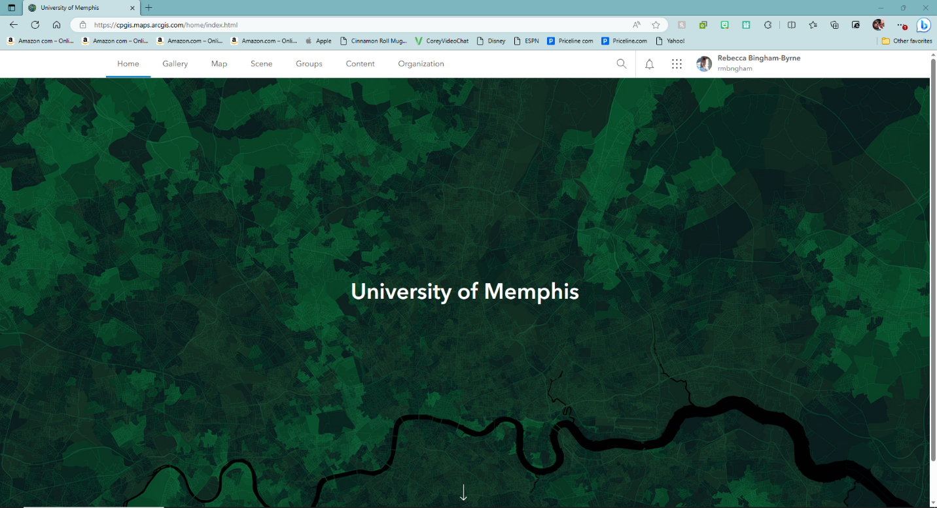

For the first part of this tutorial, you will learn how to create and access an ArcGIS Online profile.

1. Before creating your ArcGIS account, make sure to have the following information available:
   1. Your name
   2. Your email address (best to use the one provided by your university/organization)
   3. A username (can be your email address)
   4. A password with at least 8 characters. It must include at least 1 letter and 1 number. It is case sensitive and cannot be the same as your username.

*Note: you can create a public account using a social login as well, but it may be more confusing when you enter an organization later.

1. There are two ways to create an ArcGIS Online account:
   1. You can create an individual public account by following the guidelines on this page: <https://doc.arcgis.com/en/arcgis-online/get-started/create-account.htm>.
   2. If you have been invited to join an organization, you can join the organization by following the guidelines on this page: <https://doc.arcgis.com/en/arcgis-online/get-started/join-org.htm#ESRI_SECTION1_73A22DB113B7429B91101EA4D8A8E835>
2. Once your account has been established, you can access your ArcGIS Online account by signing in with your credentials on this website: <https://www.arcgis.com/index.html>

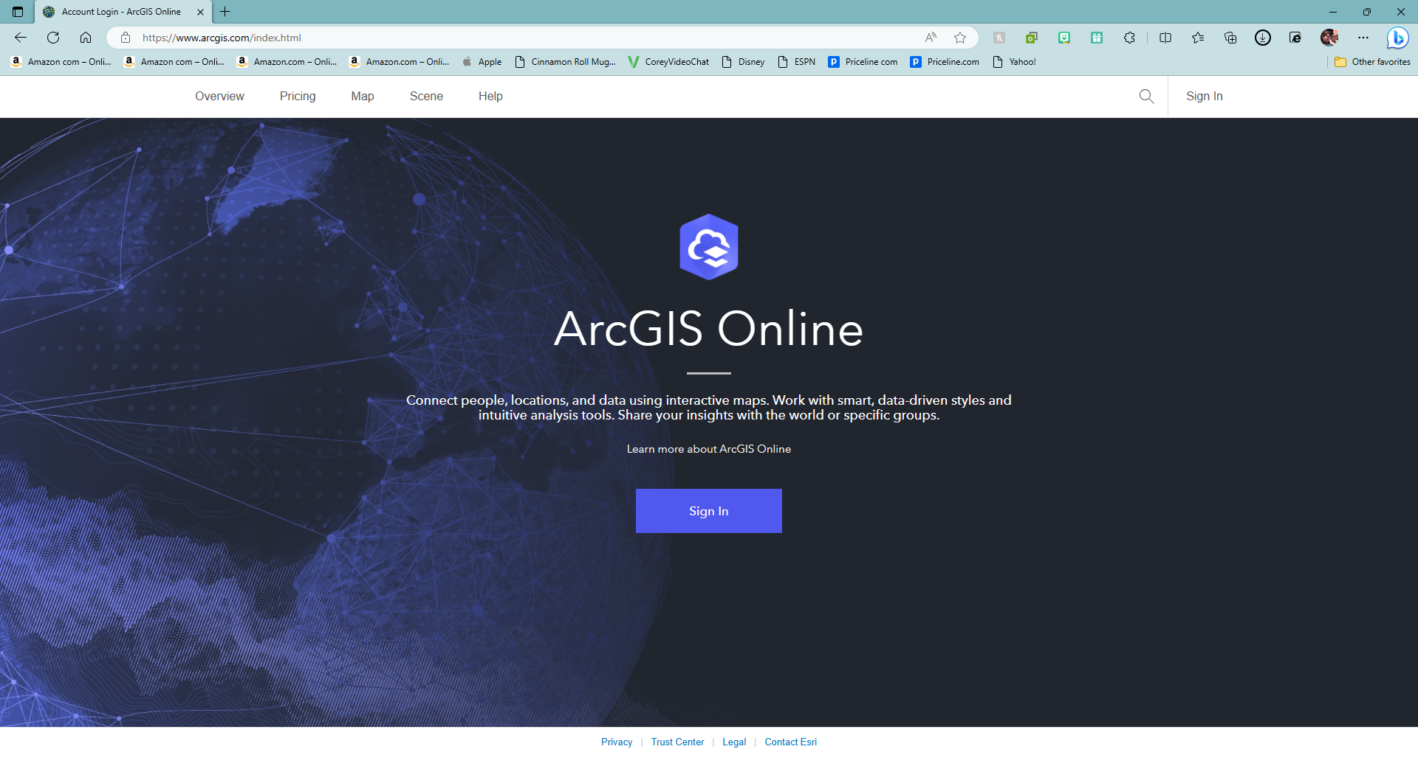

**Section 1.1 Task:** Submit a screenshot of your ArcGIS Online homepage.

## Section 1.2: Download and open ArcGIS Pro on your computer

The ArcGIS Online account credentials are also how you sign into ArcGIS Pro. Before you can use ArcGIS Pro, you will have to install the program onto your computer. To ensure successful operations of the program, please check that your computer meets the minimum specifications outlined on this page: <https://pro.arcgis.com/en/pro-app/latest/get-started/arcgis-pro-system-requirements.htm>.

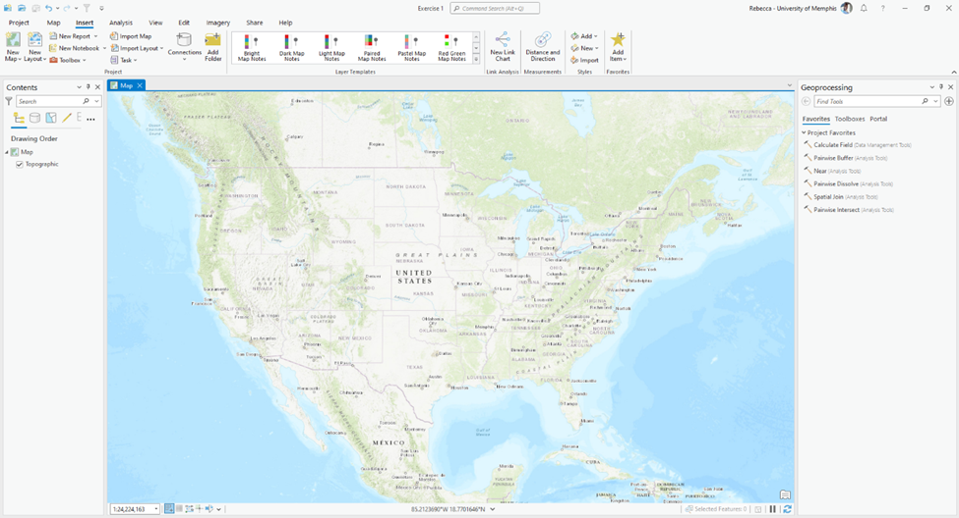

The next section of the tutorial will guide you through downloading and opening ArcGIS Pro on your computer.

1. Download the executable file (.exe) from ArcGIS Online using the guidelines under the heading described on this page: <https://pro.arcgis.com/en/pro-app/latest/get-started/download-arcgis-pro.htm>
2. After the executable file (.exe) has been downloaded onto your computer, run the file to install the ArcGIS Pro software onto your machine using the instructions found on this page: <https://pro.arcgis.com/en/pro-app/latest/get-started/install-and-sign-in-to-arcgis-pro.htm>
3. Once installed, the program will now be able to be opened, and it will look similar to the figure below.

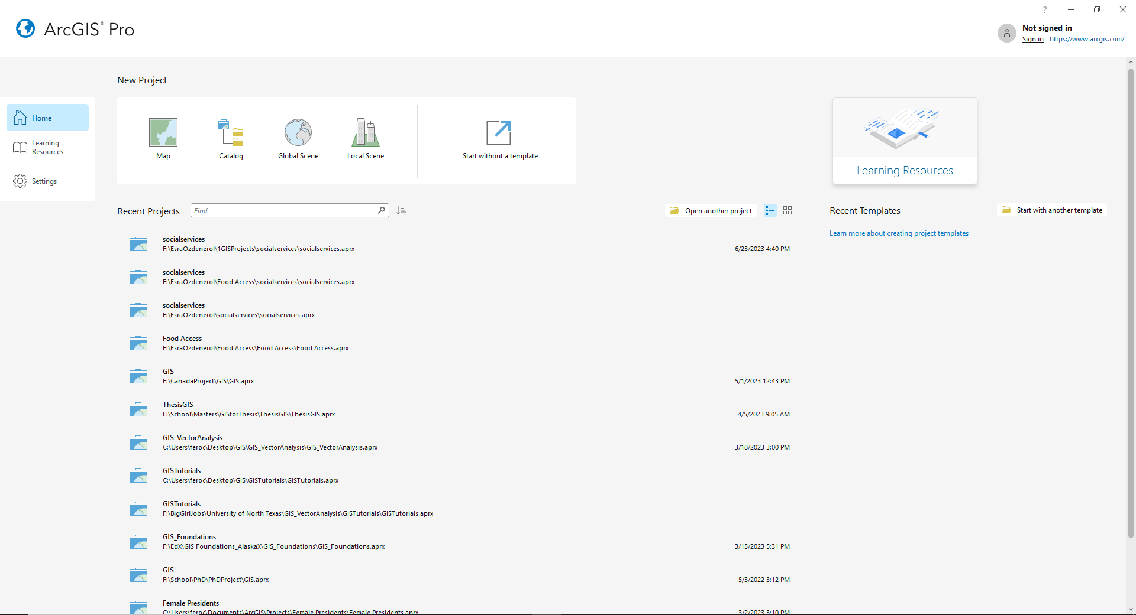

1. You will have to **sign in** to use the software. The sign in option is in the top right corner of the window. Make sure to use your ArcGIS Online credentials to sign into ArcGIS Pro.

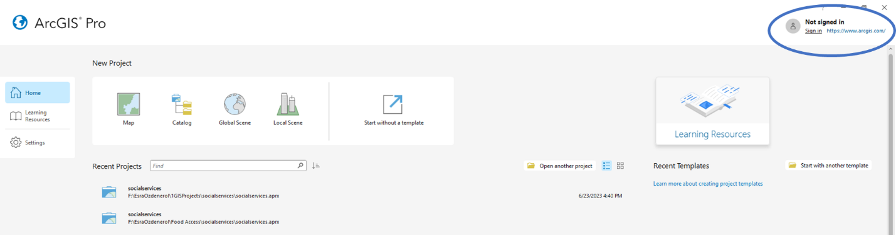

1. Next, if you click the **Map** icon, you will have the option to create a new project. You can name the project and choose where you want it to be stored. For the **Project Name**, enter “Exercise 1”. For the **location**, save it into a folder you created for the course.

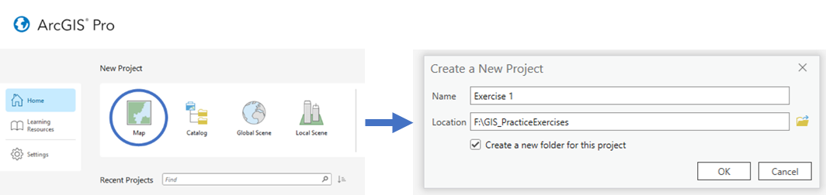

1. Once you have finished this, the software will open a new blank map.

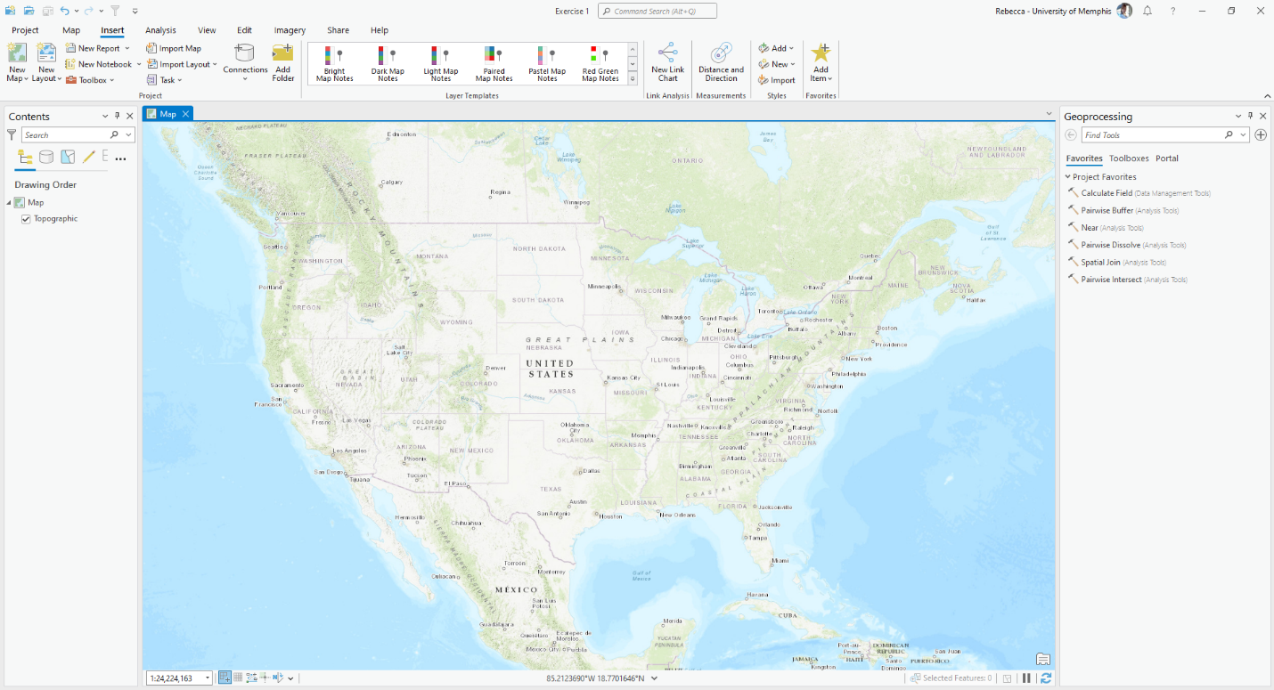

**Section 1.2 Task:** Submit a screenshot of your new blank map on ArcGIS Pro.

# Section 2: Add basemaps, vector data, and raster data to your mapping project

## Section 2.1: Adding basemaps

It is important to have a solid foundation on which users can view the location you are studying. Basemaps help users easily identify the area of focus of a map. ArcGIS provides several standard basemaps that are easily recognizable, which allows for a quick and convenient start to any mapping project.

This part of the tutorial will demonstrate how to add basemaps to your mapping project.

1. Continuing in the new blank map, you can see a basemap is already in place. You can change the basemap to better align with your needs. To do this, you click the **Map** tab along the top of the workspace.

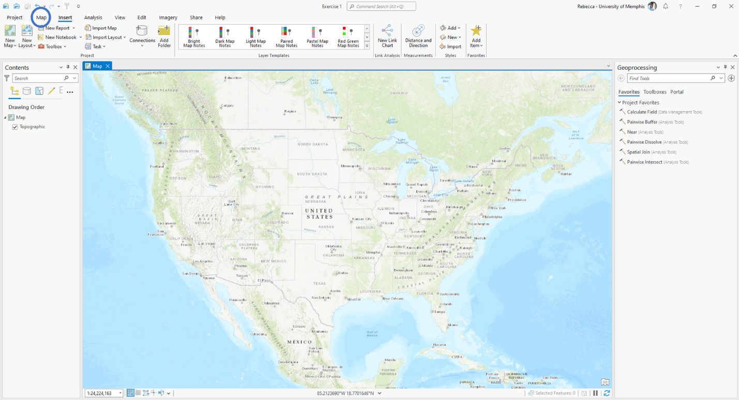

1. Click the **Basemap** icon and look at the variety of basemaps provided to you in ArcGIS Pro.

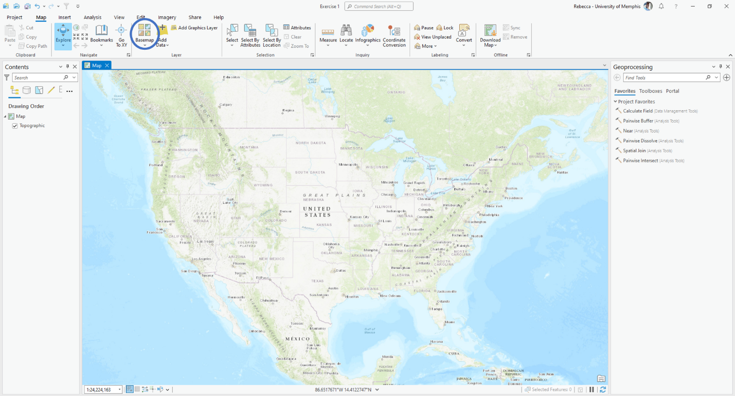

1. Choose the **OpenStreetMap** basemap from the list. **Note: the contents panel will now show OpenStreetMap instead of Topographic.**

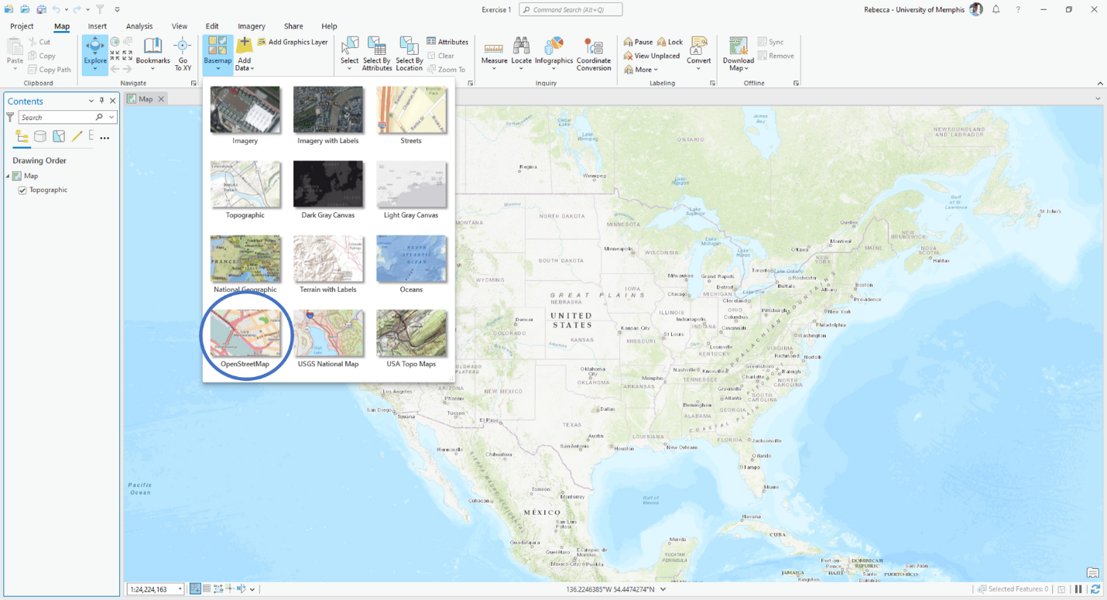

**Section 2.1 Task:** Submit a screenshot of your map on ArcGIS Pro with the OpenStreetMap basemap.

## Section 2.2: Adding vector data

Vector data can be stored in three ways: points, lines, and polygons. Points are the most basic form of vector data. Many points connected together form a line, and many lines connected together form a polygon. Each data file has the features (points, lines, or polygons) with a related table that stores all the information about those features. This table is called an attribute table. There are different ways to analyze vector data for the different types of data that is available.

This part of the tutorial will demonstrate how to add the different types of vector data to your mapping project.

1. Continuing in the map with the OpenStreetMap basemap, you will now add the **CholeraDeaths**file to the interface. To do this, you click the **Add Data** icon along the top of the workspace under the **Layer** section.

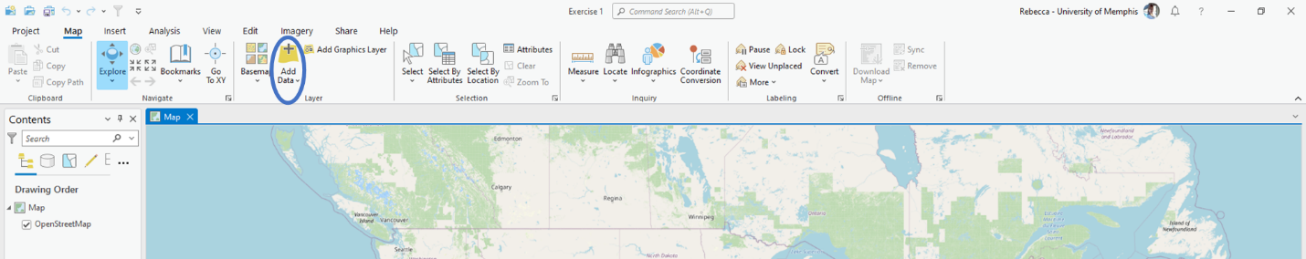

1. Next, you will need to navigate to the **JohnSnow.gdb** geodatabase that you downloaded with the tutorial data and select **CholeraDeaths** shapefile. Then click **OK**.

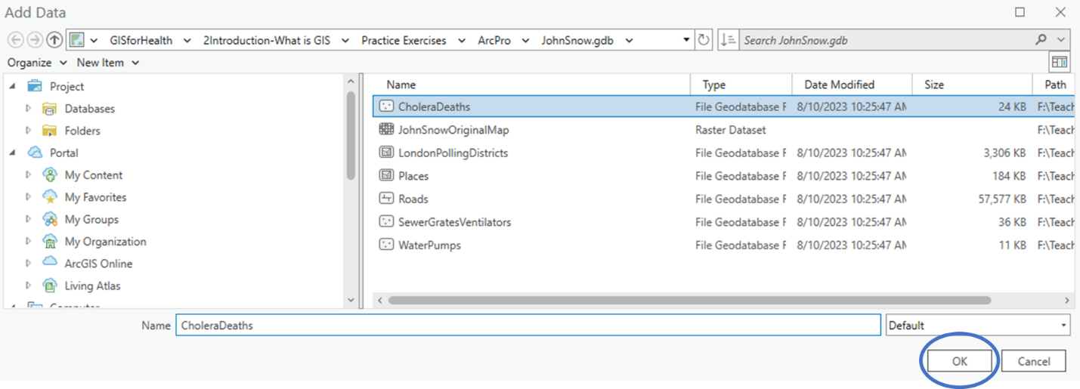

1. As you can see, this shapefile is a point location file. It stores the geographic locations of several points along with information about each point. You can see the information about each point when you open the **Attribute Table**. To do this, right click the layer name (**CholeraDeaths**) in the contents pane and click **Attribute Table**. Then review the data available for each of the points.

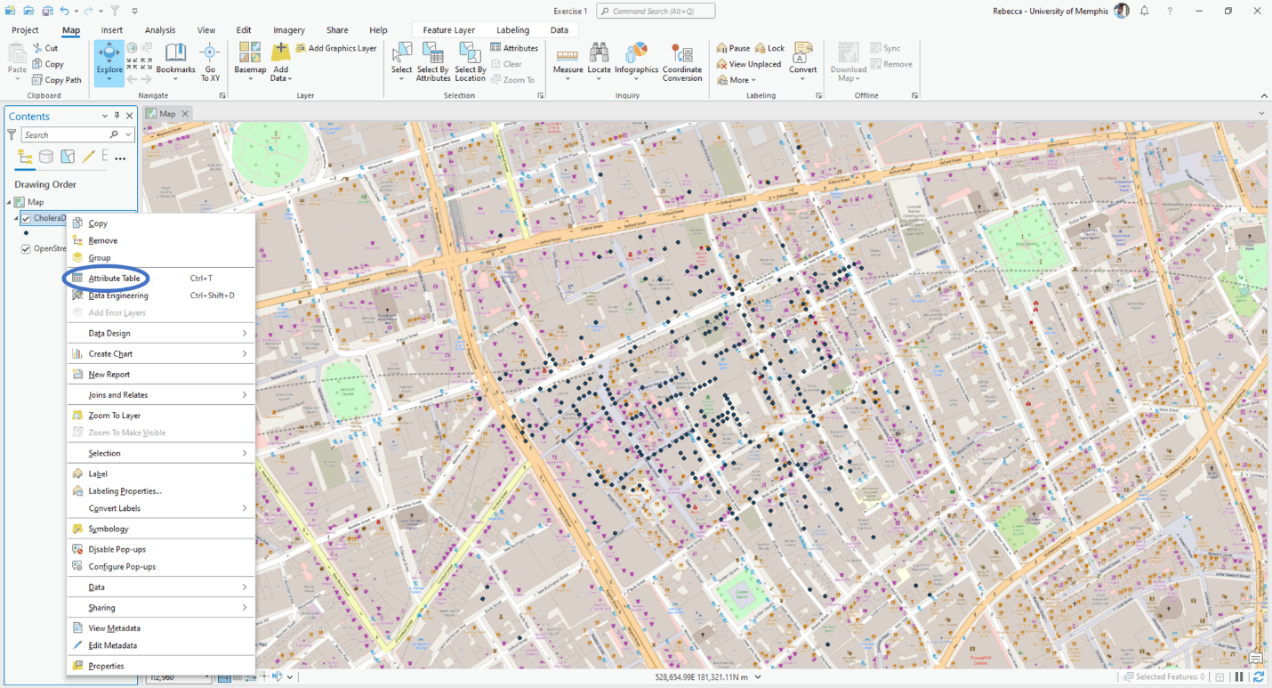

1. Next, we are going to add a line shapefile to your map called **Roads**. To do this, click the **Add Data** button again. You should still be in the **JohnSnow.gdb** folder. Here you will select the **Roads** shapefile and click **OK**. Open the **Attribute Table** and view the information that is provided for each of these lines.

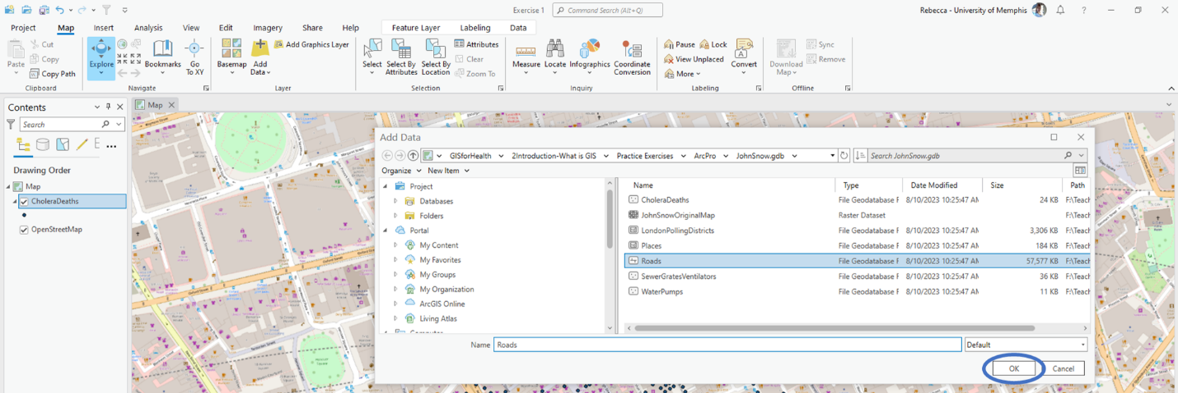

1. Finally, we will do the same process to import a polygon shapefile called **LondonPollingDistricts** into the map. Open the **Attribute Table** and view the information that is provided for each of these polygons.

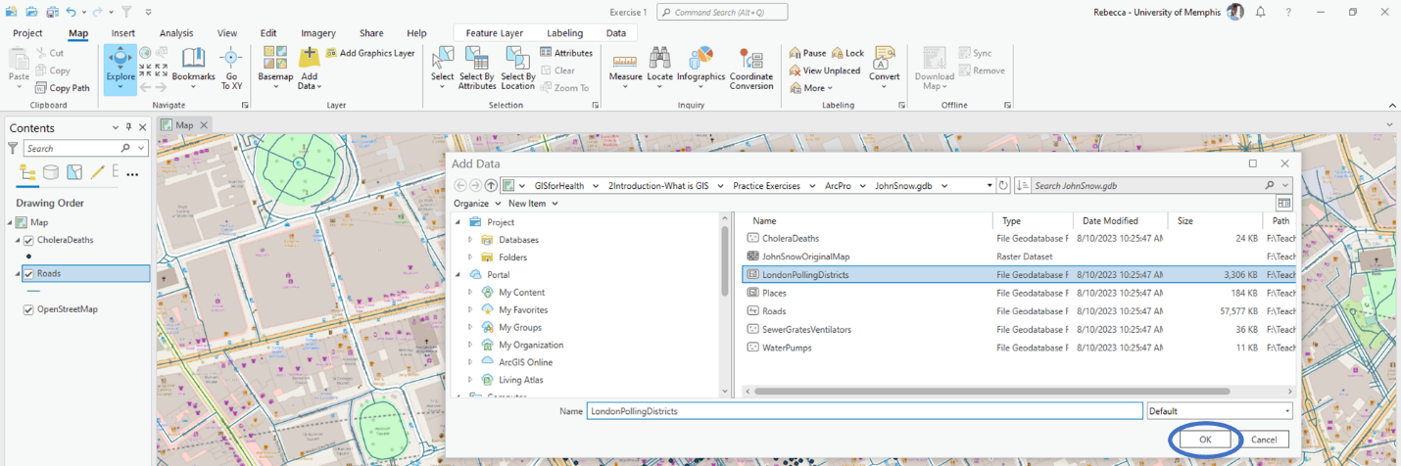

1. Next, we will learn how to change the extent you are viewing. You want to see the extent of all the data in your map. This can be done by zooming to your largest layer. To do this, you right click your largest layer (**LondonPollingDistricts**) and choose **Zoom To Layer**.

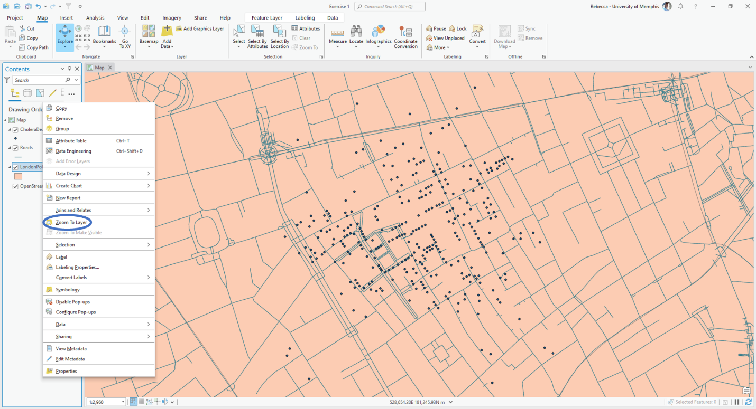

**Section 2.2 Task:** Submit a screenshot of your map on ArcGIS Pro of the full extent of your three vector layers added.

## Section 2.3: Adding raster data

Raster data is made up of pixels. You can use any image that has a red, green and blue value. You can get images of the earth via satellites that can represent land cover or use old maps and georeference them. This process involves lining up the map to a basemap to give the image location data. You can also take vector data and transform it into raster data.

This part of the tutorial will demonstrate how to add an old map that has already been georeferenced into your mapping project.

1. Continuing in your map, you will now add John Snow’s original Cholera outbreak map to the interface. To do this, you click the **Add Data** icon and select **JohnSnowOriginalMap**. Then click **OK**.

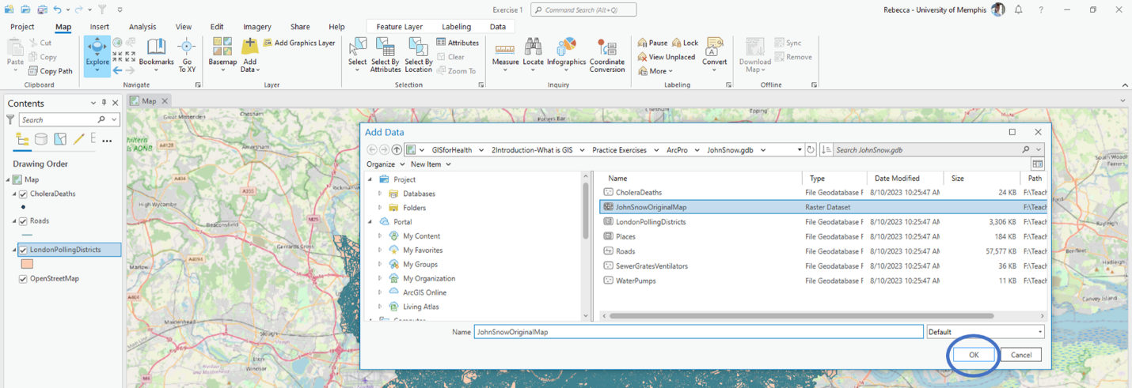

1. If you right click the layer, you will notice that the **Attribute Table** is grayed out. This is because raster data does not have ready attribute tables.

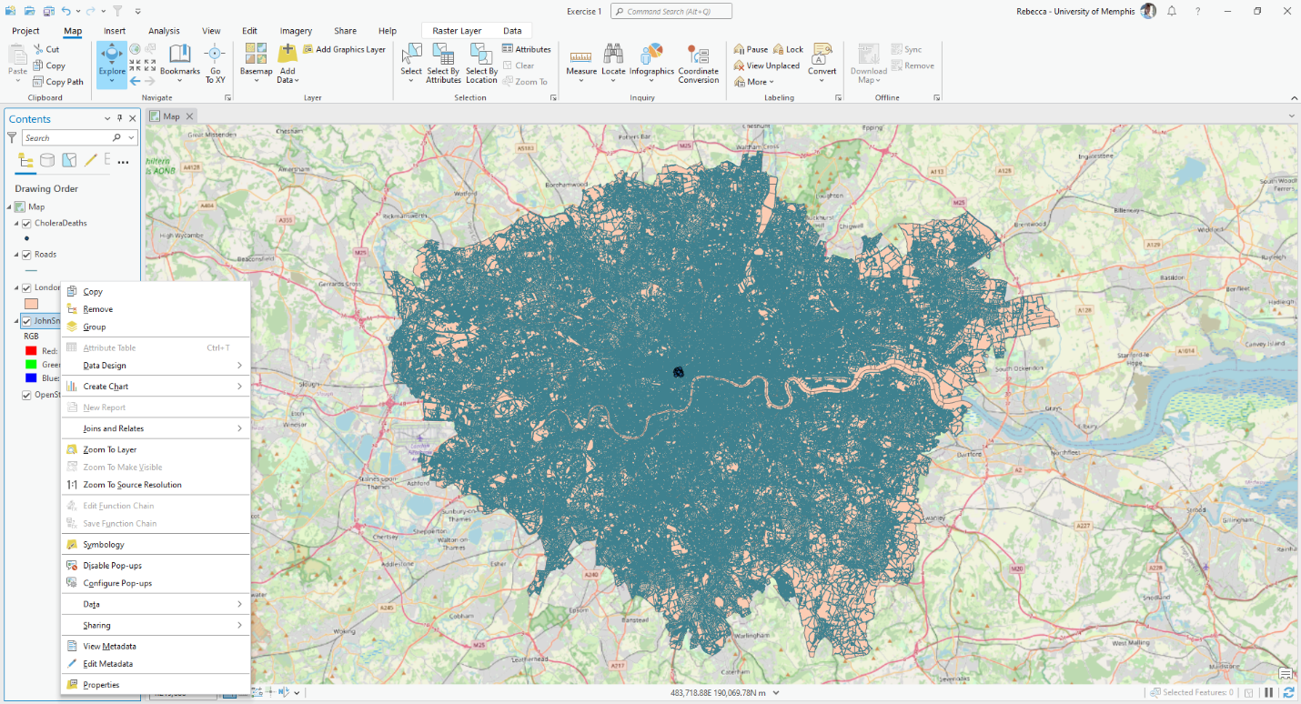

1. There are two reasons why you may not see John Snow’s original map. The first is because you have zoomed out to the full extent of the vector data, you will not be able to see the map right away. You can zoom into the map by right clicking **JohnSnowOriginalMap** in the contents pane and selecting **Zoom To Layer**. If you still cannot see the map, you will have to rearrange the layers in the content pane. To do this, click and hold **JohnSnowOriginalMap** and drag it to the top of the list.

**Section 2.3 Task:** Submit a screenshot of your map on ArcGIS Pro of the zoomed into **JohnSnowOriginalMap** with the original map at the top of the drawing order.

# Section 3: Working in the ArcGIS Environment

## Section 3.1: View and edit metadata for layers in ArcGIS Pro

Metadata, put simply, is data about data. This stores information such as what the data is, when it was developed, and who created it. It is very important to keep up with metadata for spatial data, especially if the data is to be shared in the future with other people or groups.

This part of the tutorial will demonstrate how to view and edit metadata for layers in ArcGIS Pro.

1. Continuing in your map, you will now look at the metadata for each of the layers. To do this, you right click the layer in question and select **View Metadata**. Start with **CholeraDeaths**.

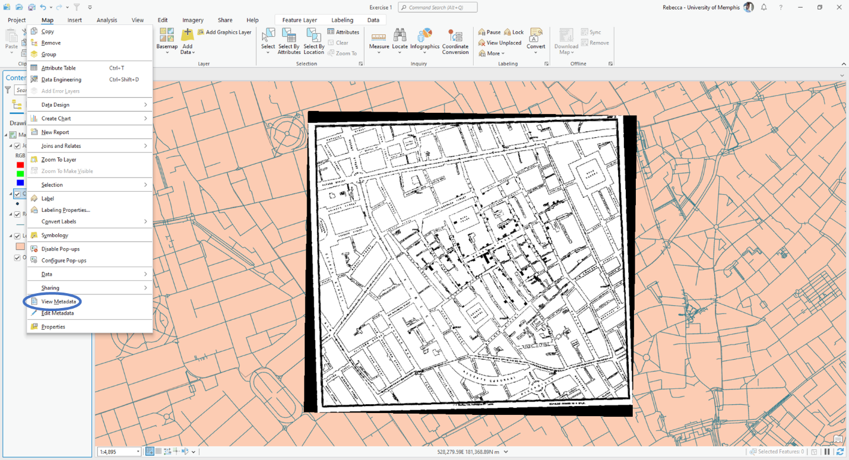

You will notice that you can switch between the layers in the **Catalog** tab that has popped up. While looking at **CholeraDeaths**, you can see that it has a Title along with information about its Type, Tags, Summary, Description, Credits, Use limitations, Extent, and Scale Range. The metadata for this shapefile has been updated and maintained as recommended. Now begin looking at the metadata for the other layers.

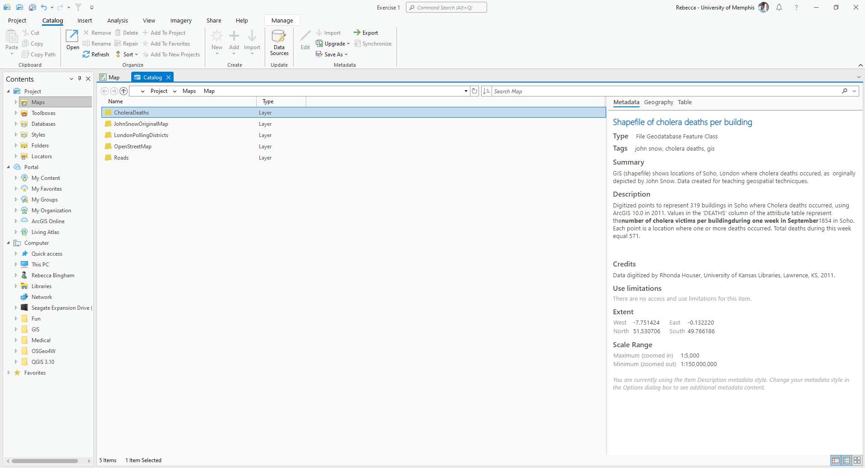

1. You will notice that some of the other layers are not as well kept. We must enter in Metadata for these files. To do this, we must first change the layer’s properties to assign the layer its own metadata instead of copying the source metadata. First, close the **Catalog** tab. Then, right click **JohnSnowOriginalMap** in the contents pane and select **Properties**. Then, from the drop down menu at the top, choose **Layer has its own Metadata** and click **OK**.

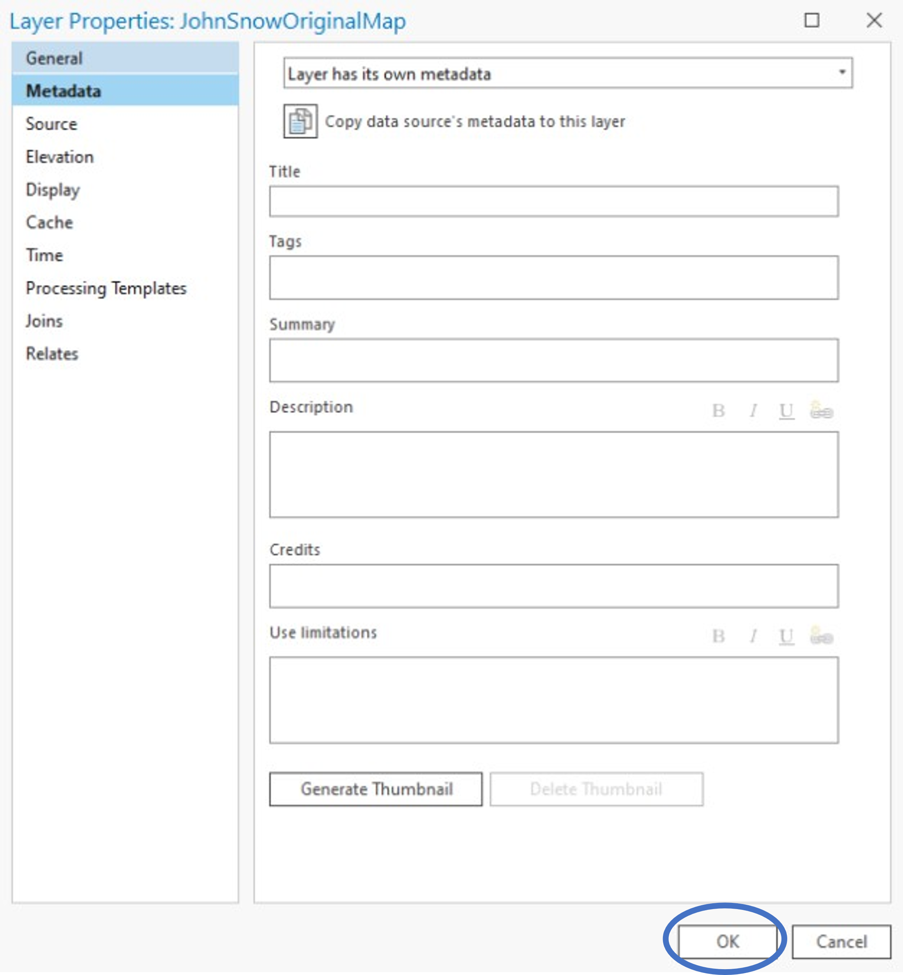

1. Next, click the **View** tab at the top of the ArcGIS Pro interface. Then click **Catalog View**.

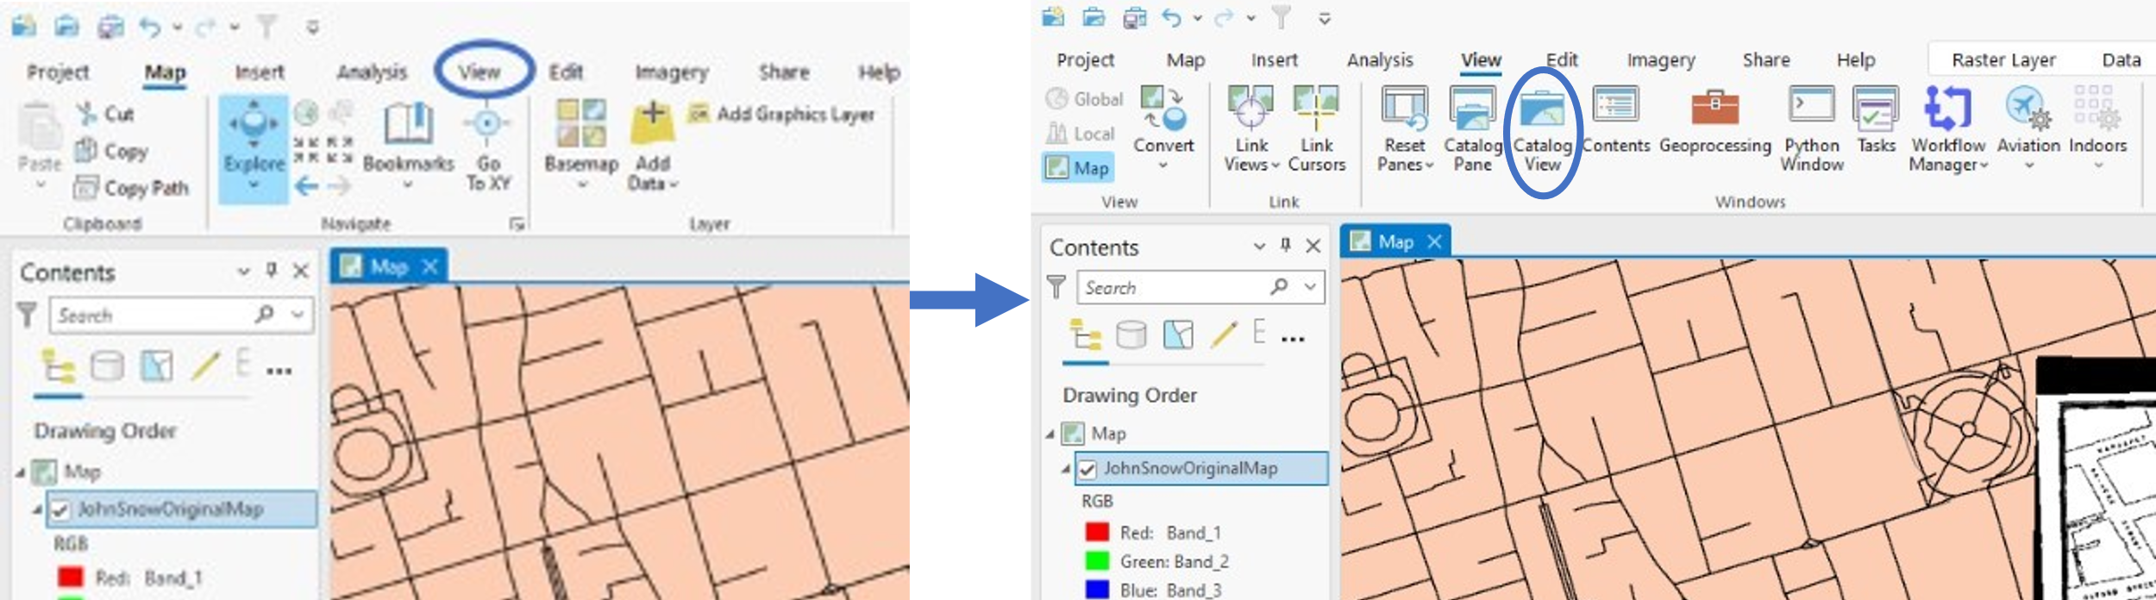

1. Next, you will need to navigate to the folder for the **JohnSnow.gdb**. You can then edit the metadata by right clicking **JohnSnowOriginalMap** and selecting **Edit Metadata**.

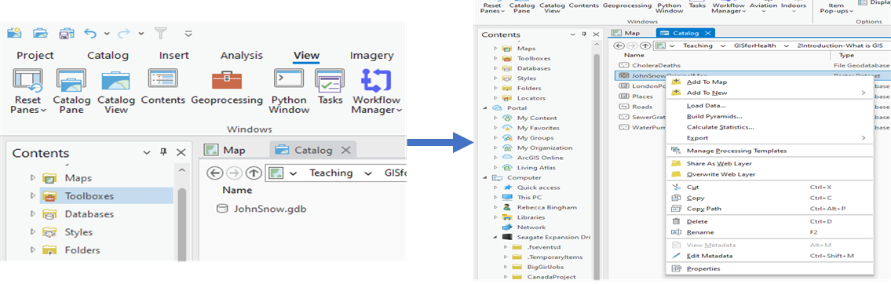

1. Fill in the metadata according to the figure below then close the **JohnSnowOriginalMap** tab. It should ask you if you want to save your changes. Click **Yes**.

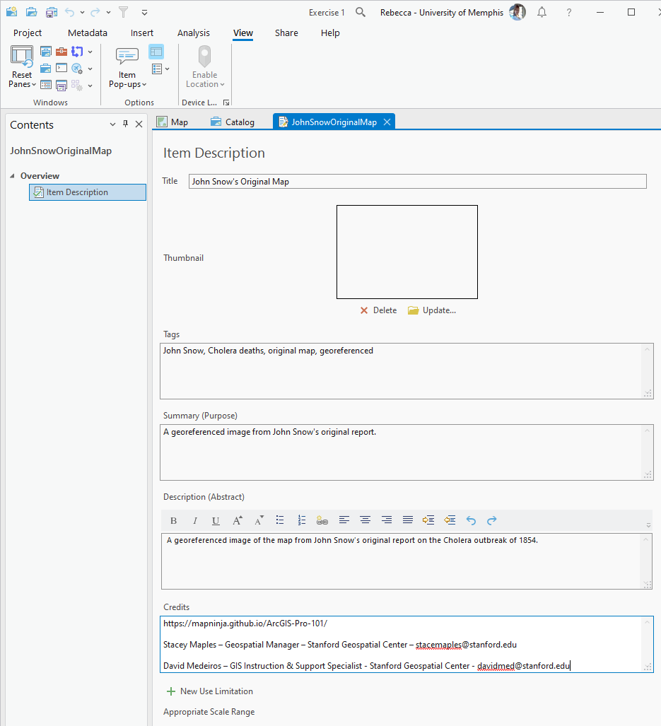

1. In Catalog **View**, you will now see the newly entered metadata if you click on the **JohnSnowOriginalMap** layer.

**Section 3.1 Task:** Submit a screenshot of the metadata you entered for the **JohnSnowOriginalMap**.

## Section 3.2: Select certain features from a layer

One of that will make the finished maps look crisp and clean is making sure that all the layers you have added to the map cover the same area. There are a few tools that can help you select certain parts of a layer (the **Select** tools). Then you can create temporary layers from those selected features.

This part of the tutorial will demonstrate how to select specific features from a layer using the **Select** tools in ArcGIS Pro. Then create a temporary layer of those selected features.

1. Continuing in your map, you see that there are two layers that reach much further throughout the map than the rest: **Roads** and **LondonPollingDistricts**. We want to reduce these two layers to show only our areas of interest. There are three helpful tools that allow us to select features from a layer: **Select**, **Select By Attributes**, and **Select by Location**. They are all located in the **Selection** section of the toolbar at the top of the ArcGIS Pro environment.

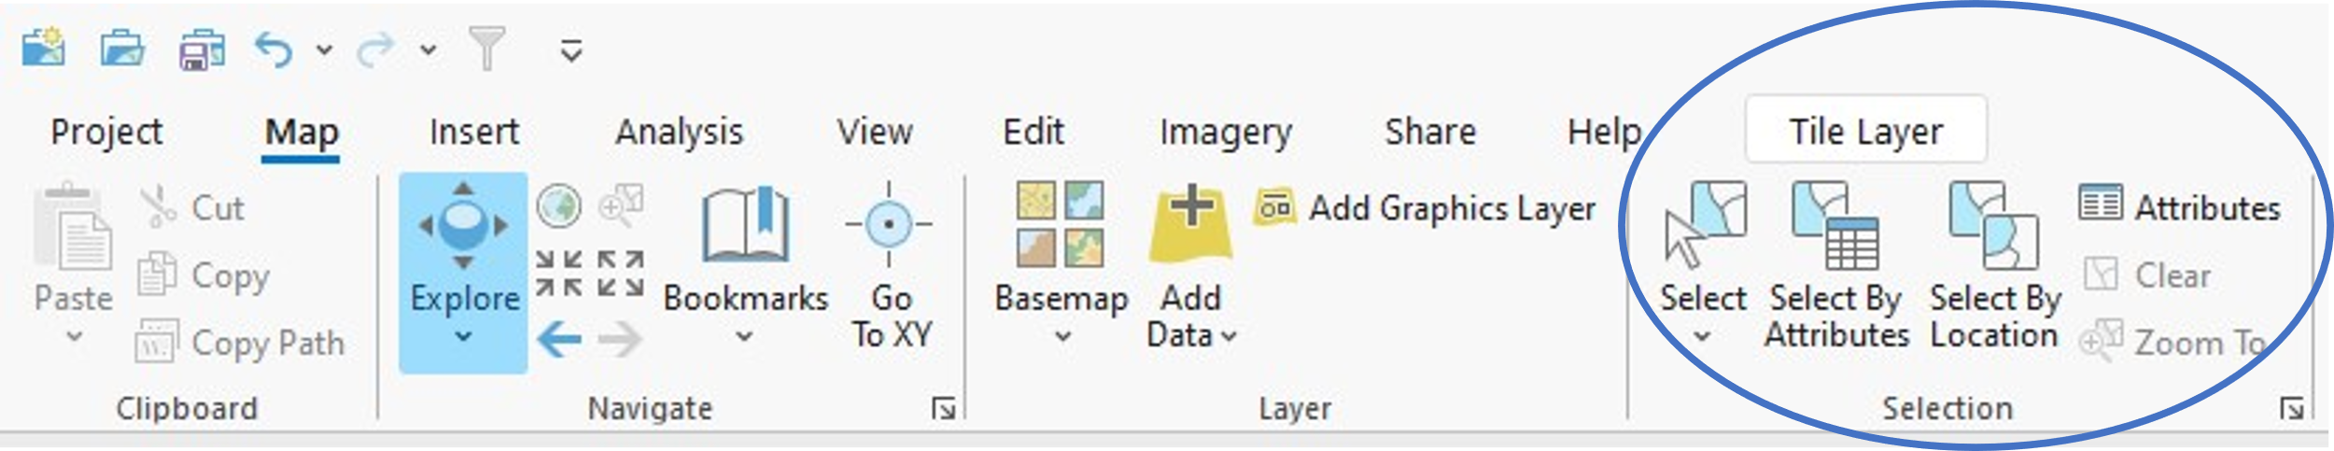

1. Let’s start by narrowing down the polling districts to only those found within the area of interest. First, click the **Select By Attributes** tool. Then, in the **Input Rows** section select **LondonPollingDistricts**. Using the drop-down menu next to **Where**, select **PD_ID** and search for **WEA** in the drop down menu next after **is equal**. It will look according to the figure below.

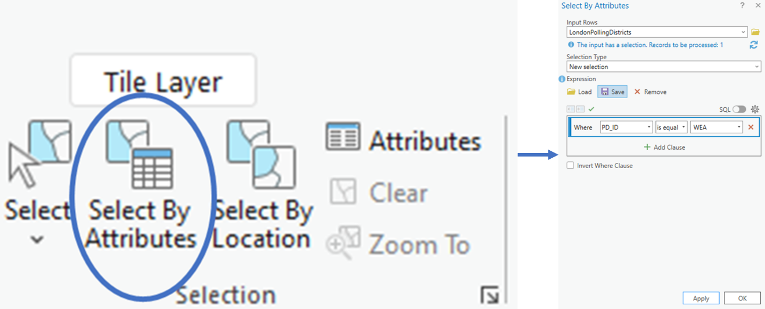

1. Next, click the **Apply** button to apply the selection. This will select only the features whose **PD_ID is equal to WEA**. These features will have a colored ring around them to show that they are selected. It may be hard to see which features are selected. You can zoom into those selected features by right clicking the layer (**LondonPollingDistricts**), hover over **Selection**, then click **Zoom to Selection**. **NOTE\*\*** In the figure below, it is highlighted in red, yours may be highlighted in a different color such as blue.

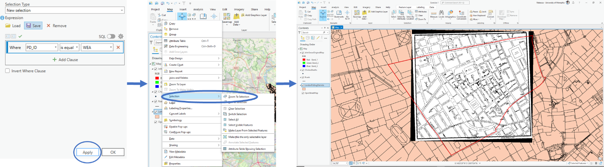

1. Next, you will want to make a temporary layer out of the selected features. To do this, by right clicking **LondonPollingDistricts**, hovering over **Selection**, and clicking **Make Layer From Selected Features**. The temporary layer automatically gets added to the top of the drawing order in your map and it will be named **LondonPollingDistricts selection**.

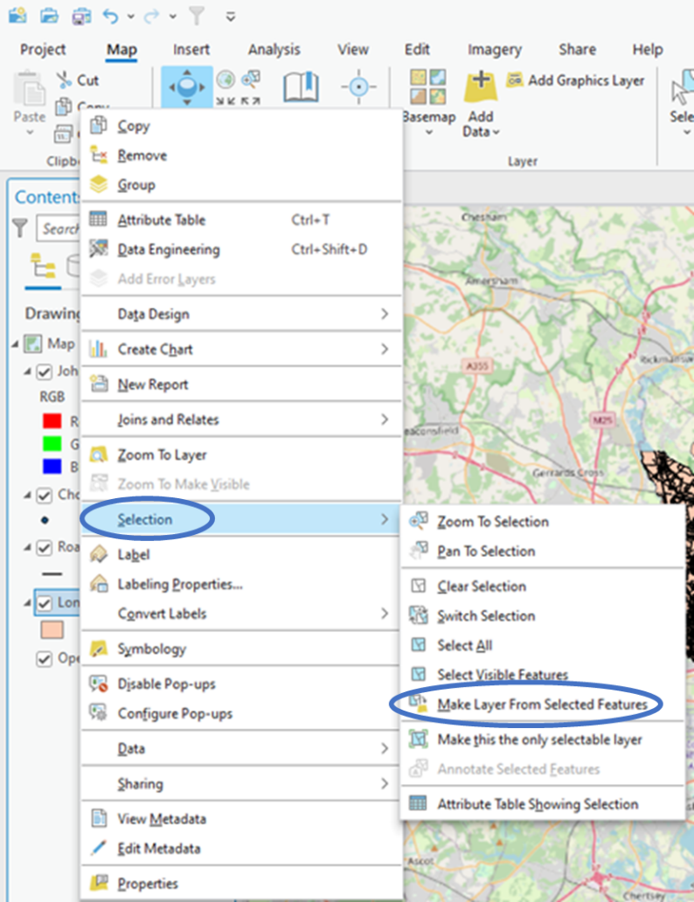

1. Now it is time to select only the roads in the area of interest. Before working on this, you must clear the selected features from before. Choose the **Clear** tool in the **Selection** section at the top of the ArcGIS Pro work environment.

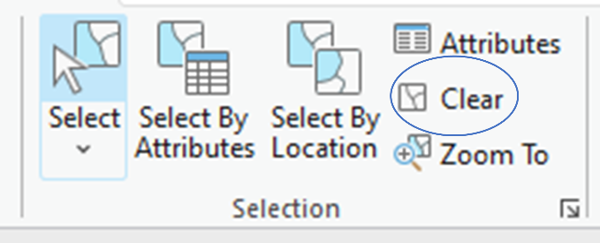

1. To do this, choose the **Select By Location** tool in the **Selection** section at the top of the ArcGIS Pro work environment. Then, in the **Input Features** section make sure **Roads** is selected. Under the **Relationship** section, use the drop-down menu to select **Within**. Next, use the drop-down menu under **Selecting Features** to choose **LondonPollingDistricts selection**. When finished it will look according to the figure below.

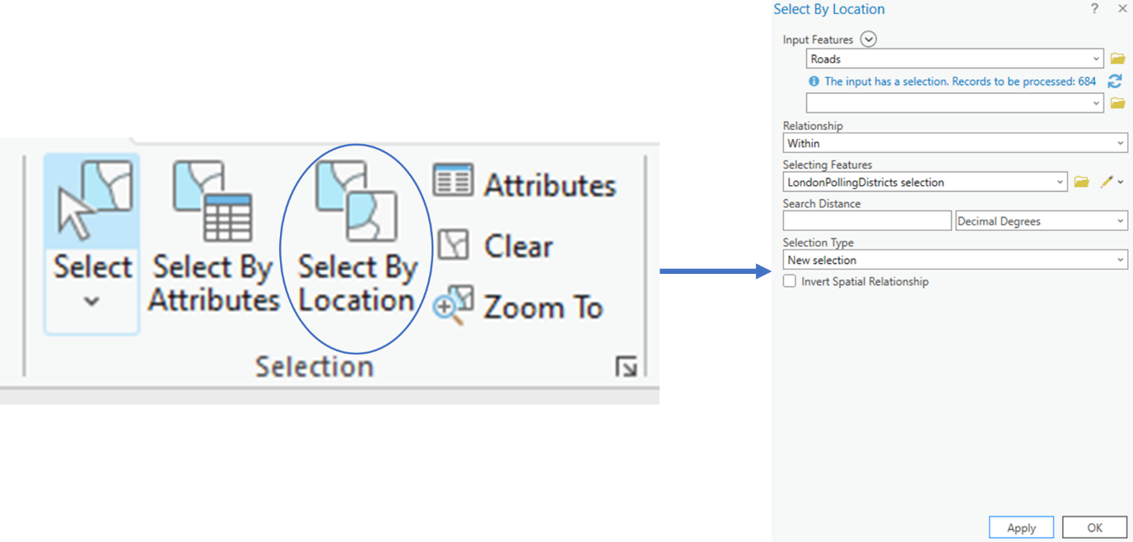

1. Next, click the **Apply** button to apply the selection. Then click **OK.** This will select only the features in the **Roads** layer that fall **within** the outline of the **LondonPollingDistricts selection** layer. These features will be highlighted to show that they are selected. **NOTE\*\*** In the figure below, it is highlighted in red, yours may be highlighted in a different color such as blue.

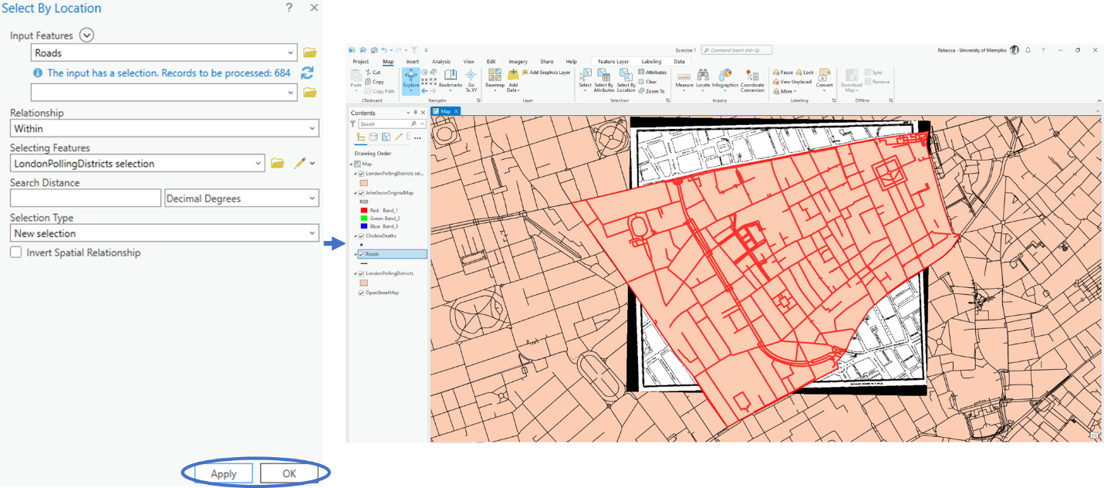

1. Next, you will want to make a temporary layer out of the selected features in the same manner as when working with the **LondonPollingDistricts**. This temporary layer will be named **Roads selection**.

**Section 3.2 Task:** Submit a screenshot your map with the **LondonPollingDistricts selection** and **Roads selection** layers at the top of the drawing order.

## Section 3.3: Export spatial data and maps

One of the main areas of science that generally gets overlooked is sharing your work with others. In geospatial sciences, you can share your work with others by exporting the spatial data you have worked on as new shapefiles or by exporting the finished maps to allow people a visual representation of the data.

This part of the tutorial will demonstrate how to export spatial data and maps in ArcGIS Pro.

1. You had created a layer from selected features that you may want to use in the future in another map, or others may want to use later. To be able to use it in future maps, you must export the temporary layer to make a permanent shapefile in your geodatabase. You can export the data to create a permanent layer within your geodatabase. To do this, you will right click the temporary layer (**LondonPollingDistricts selection**), hover over **Data** and click **Export Features**.

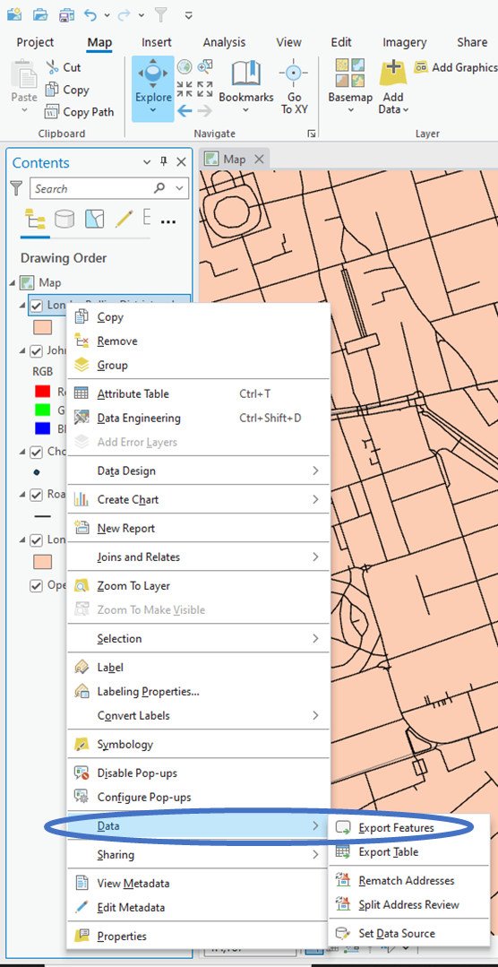

1. A window will pop up with information to fill out. Here you keep the **Input Features** the same. For the **Output Feature Class**, click the folder icon towards the right side of the entry box.

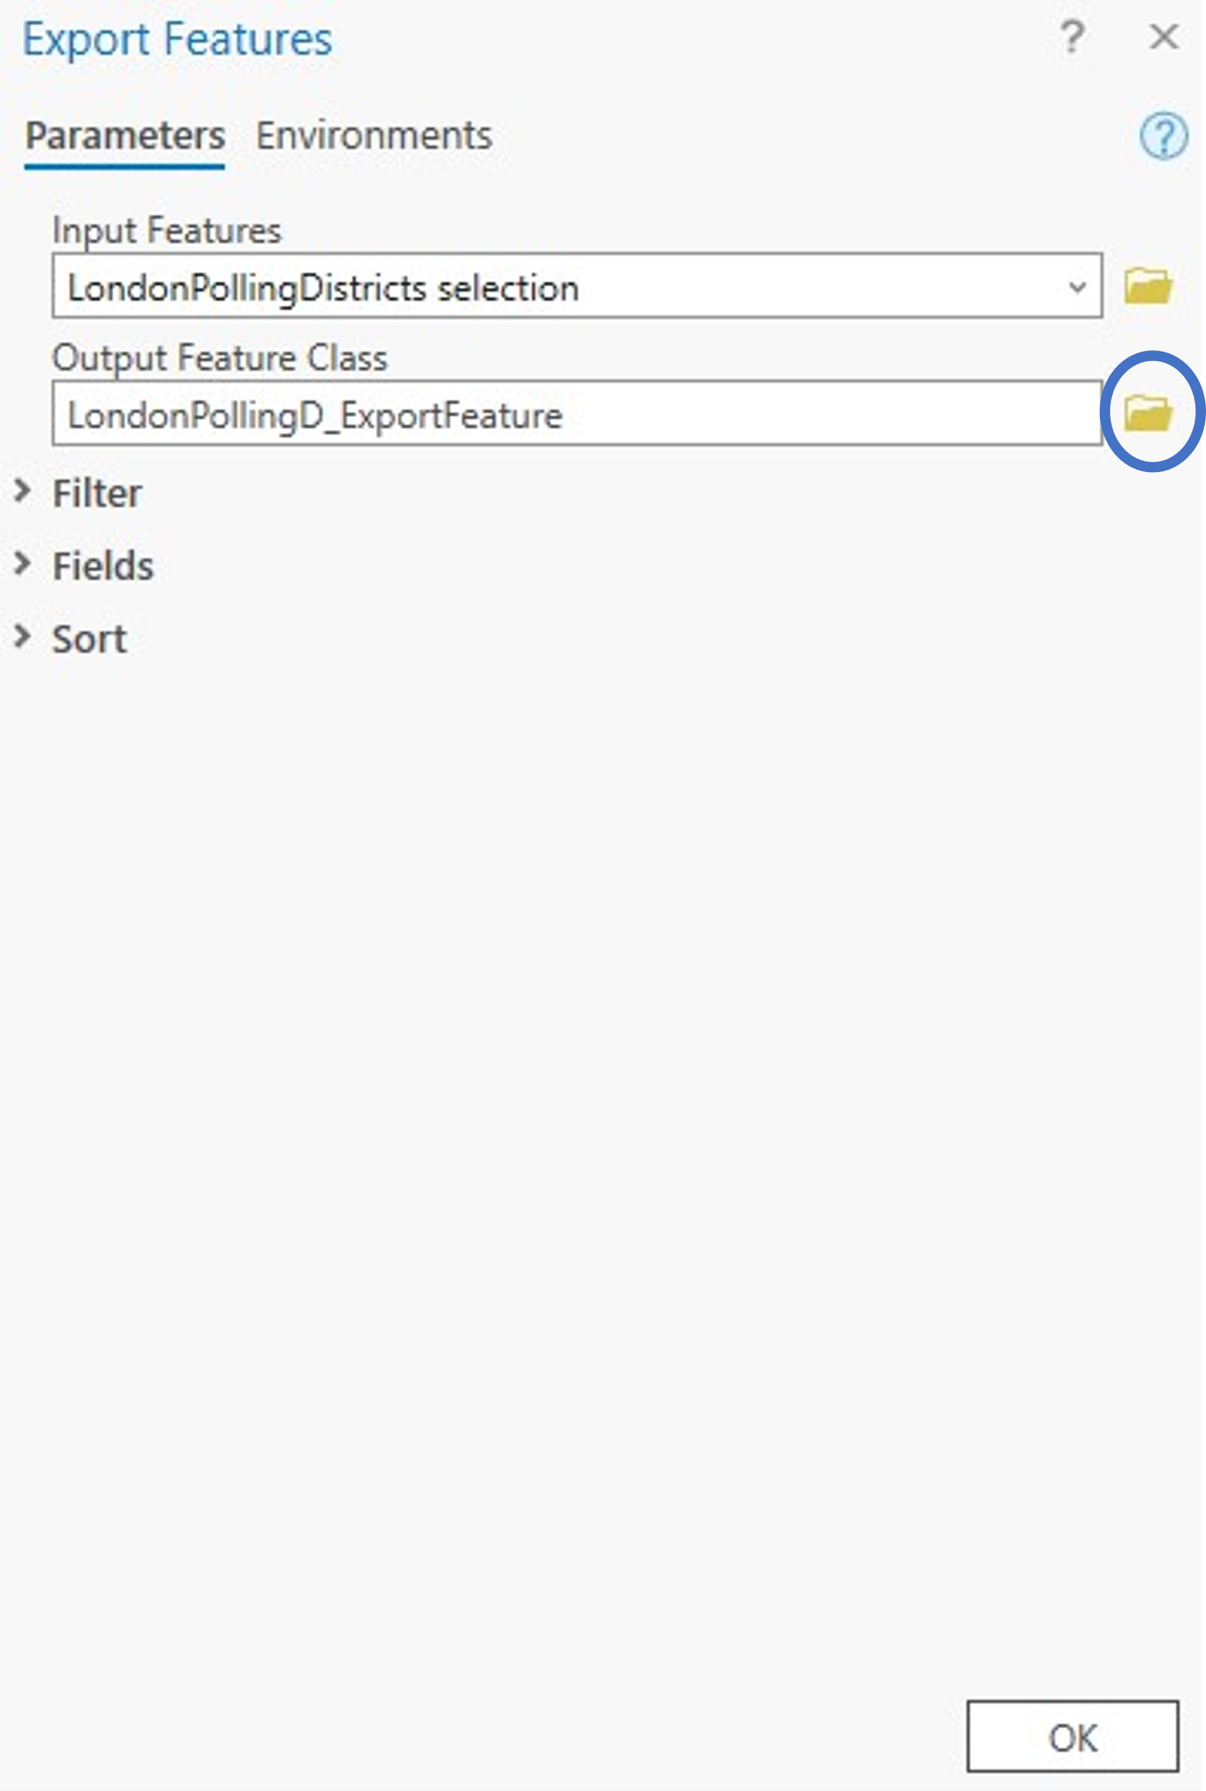

1. Navigate to the folder for the **JohnSnow.gdb** and name the layer **StudyArea**. Click **Save**, then **OK**. You now have a new permanent shapefile that outlines your study area in your geodatabase. You will notice that the new permanent shapefile automatically gets added towards the top of your map.

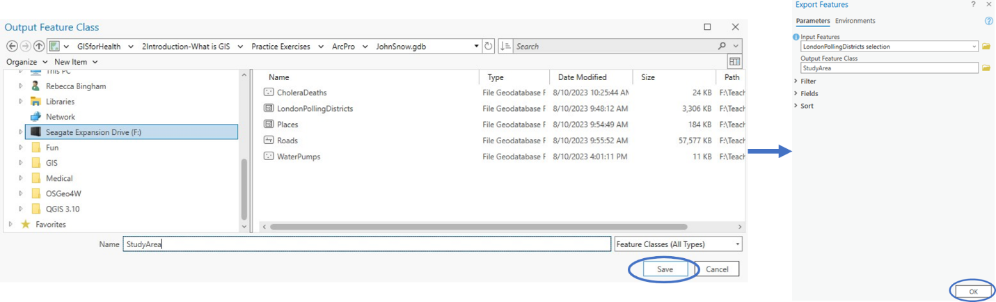

1. Do this for the **Roads selection** layer as well using the information below in the **Export Features** window.

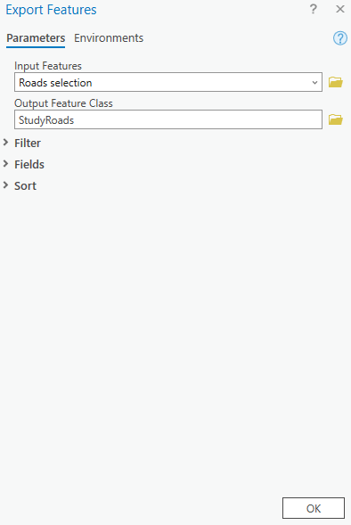

1. Move **CholeraDeaths** to the top of the drawing order. Unheck the boxes next to the other layers besides **CholeraDeaths**, **Roads**, and **StudyArea** to hide them.

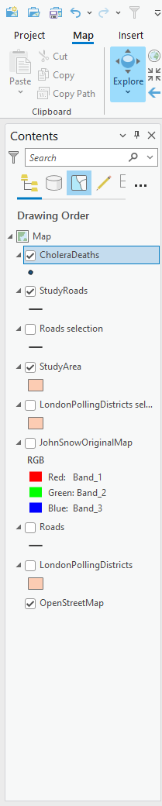

**Section 3.3 Task:** Submit a screenshot your map.